**“Index”**

##### **A MINI PROJECT REPORT**

###### **Submitted by**

Jayashree H Acharya [4NM18MCA69]

Harshita Tina D’Souza [4NM18MCA67]

##### **MASTER OF COMPUTER APPLICATIONS**

**(An Autonomous Institution Affiliated to VTU Belgaum)**

NMAM INSTITUTE OF TECHNOLOGY

Nitte Mahalinga Adyanthaya Memorial Institute of Technology, Nitte

Department of MCA

APRIL 2019

1. **Title of the Project:**

Index

1. **Introduction:**

This is an Index for Users that allows them to read the contents in the chapters whenever required. Users can directly open the file to read, to modify the contents instead of maintaining the book to read. User can read the contents by documents file or by Image. The objective of the Index is to fetch the contents or read the contents in convenient way. The main purpose of the project to build an application to reduce the manual work for managing records.

1. **Existing System:**

Existing system of Index is works with manually with pen-paper, etc. Maintaining the records is more difficult task. This creates a very hectic procedure to manage as everything is on spreadsheets, file and folders.

Whenever User require file or details of the topic he should search for book or website. This take more time to fetch the contents and read the contents. All the work is done by manually.

1. **Proposed System:**

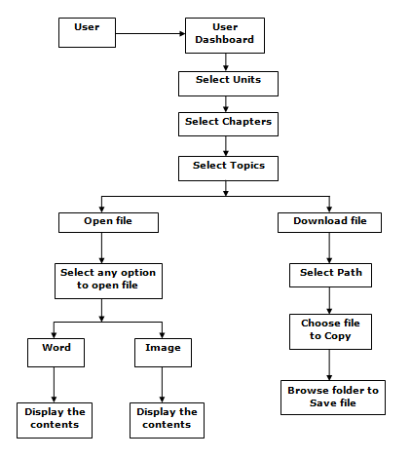

1. **Screen Shots:**

**User Page:**

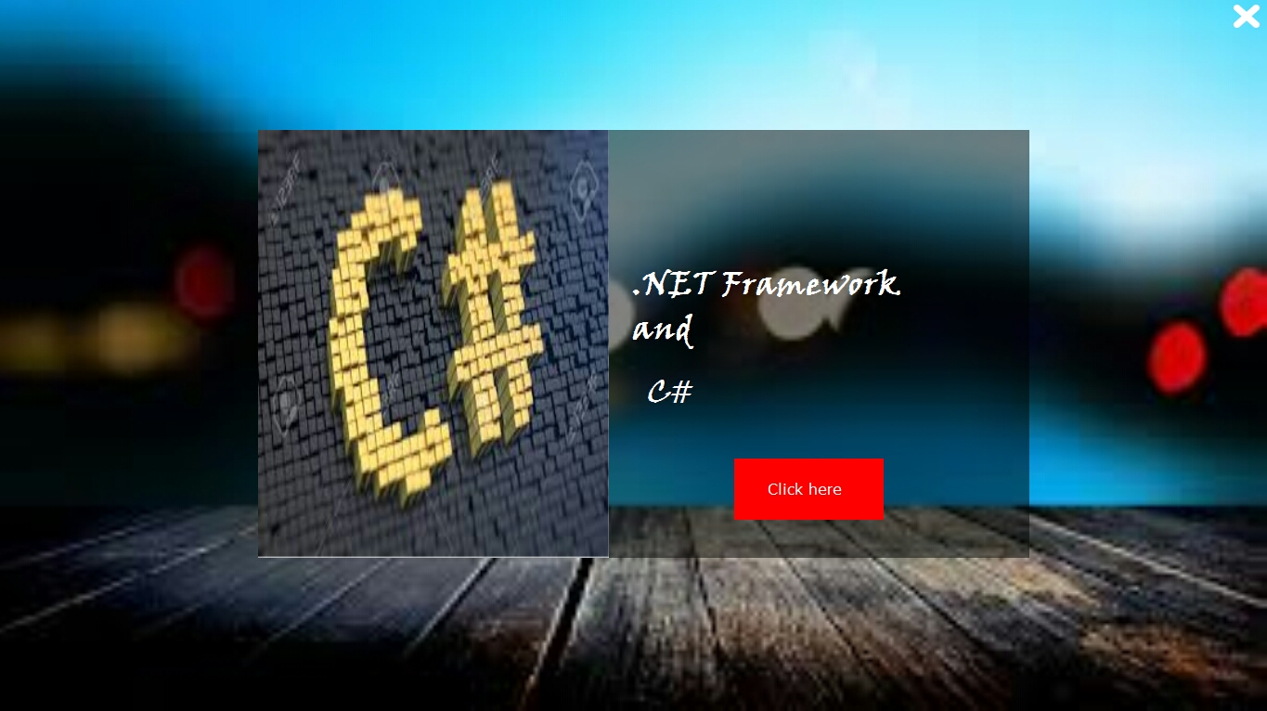

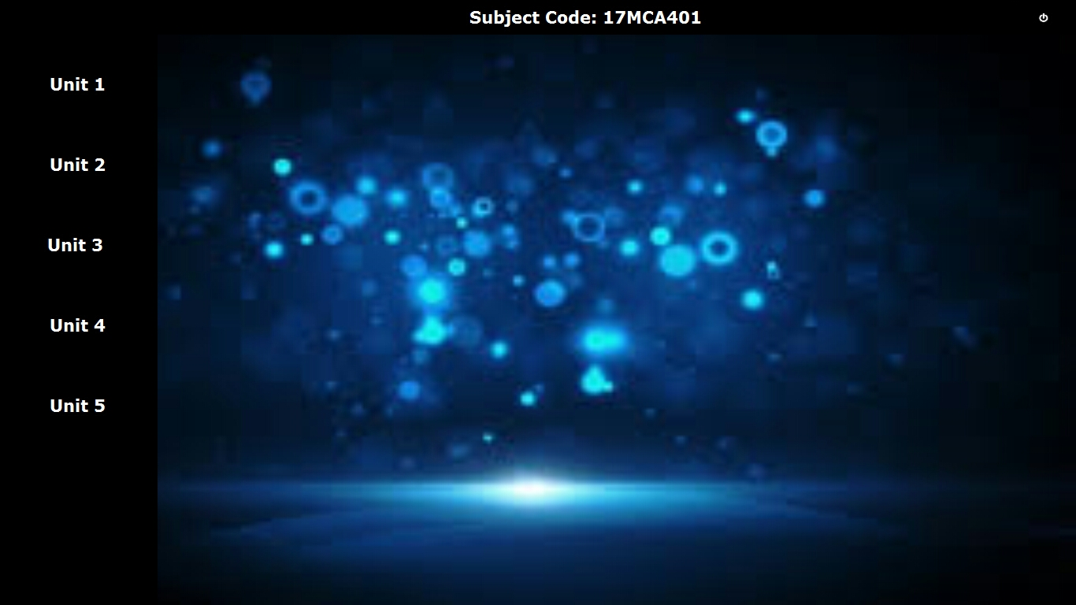**User’s Dashboard Page:**

**Unit 1 Chapters Page:**

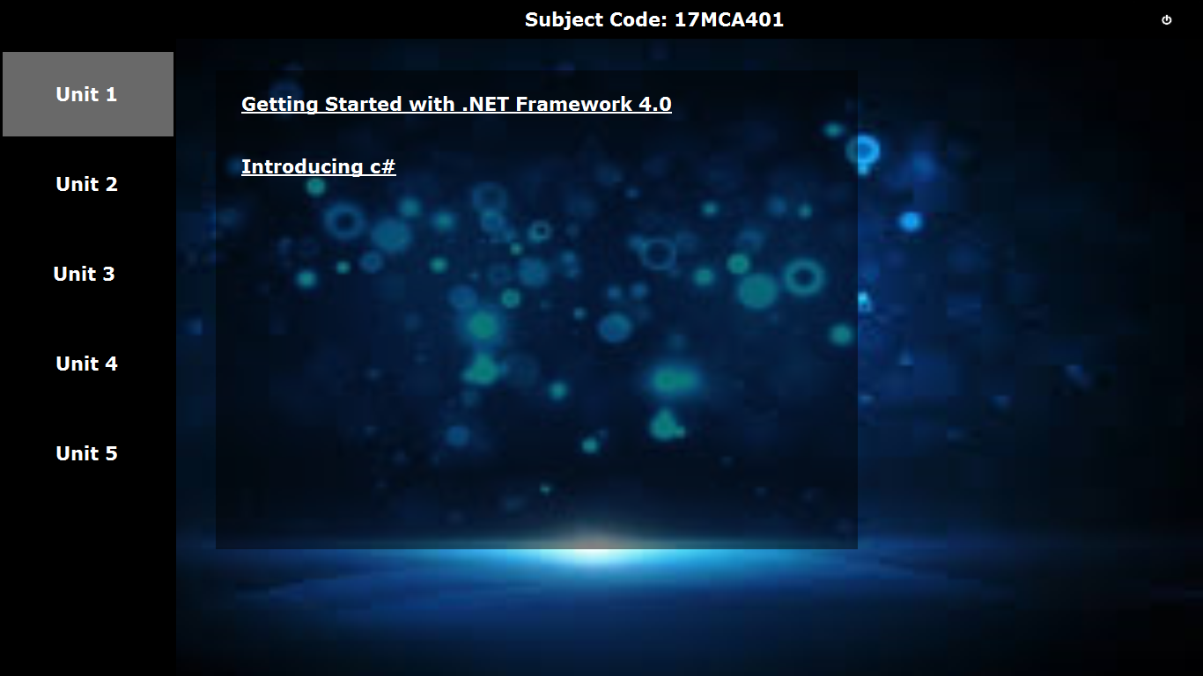

**Unit 2 Chapters Page:**

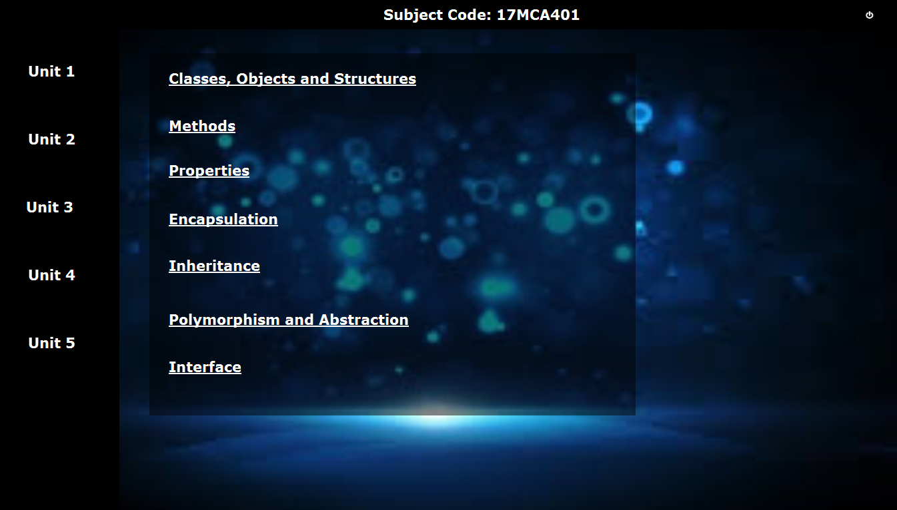

**Unit 3 Chapters Page**

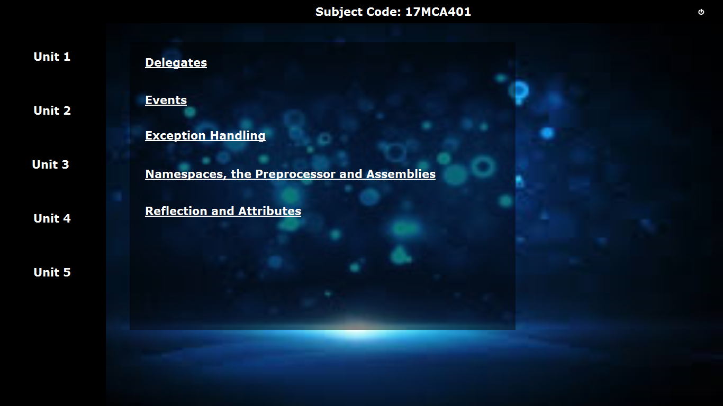

**Unit 4 Chapters Page:**

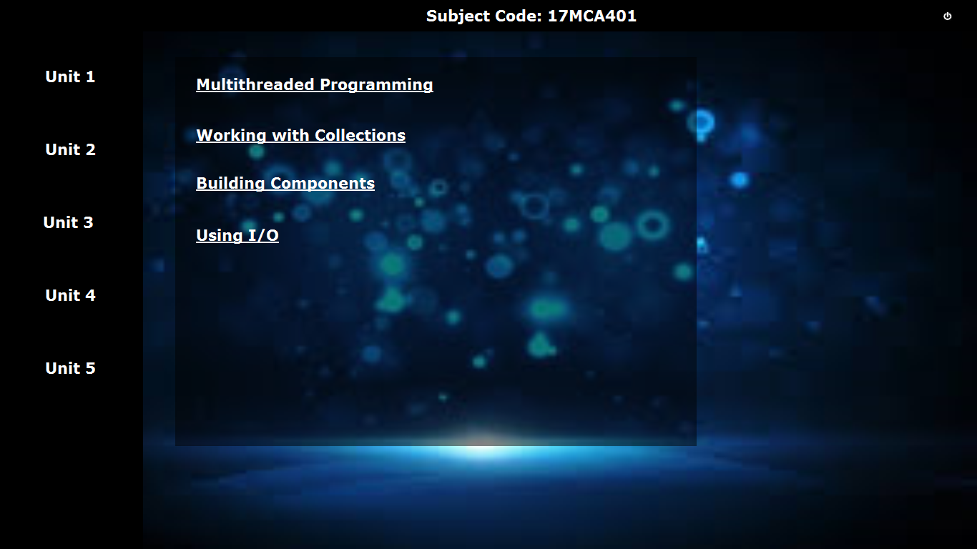

**Unit 5 Chapters Page:**

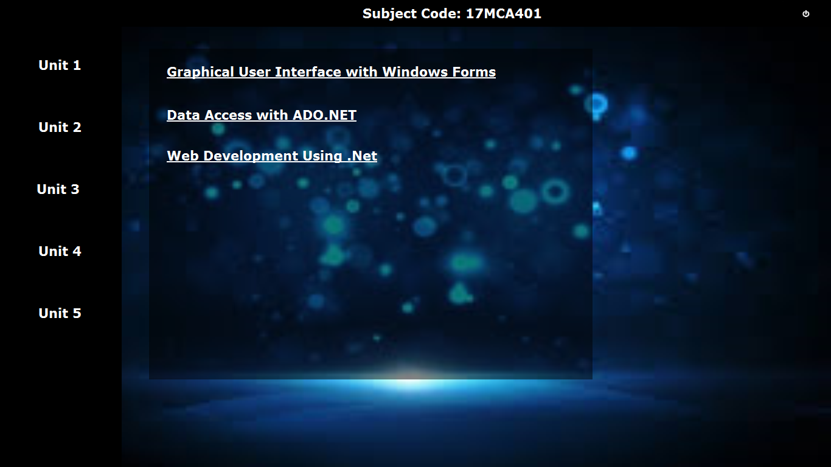

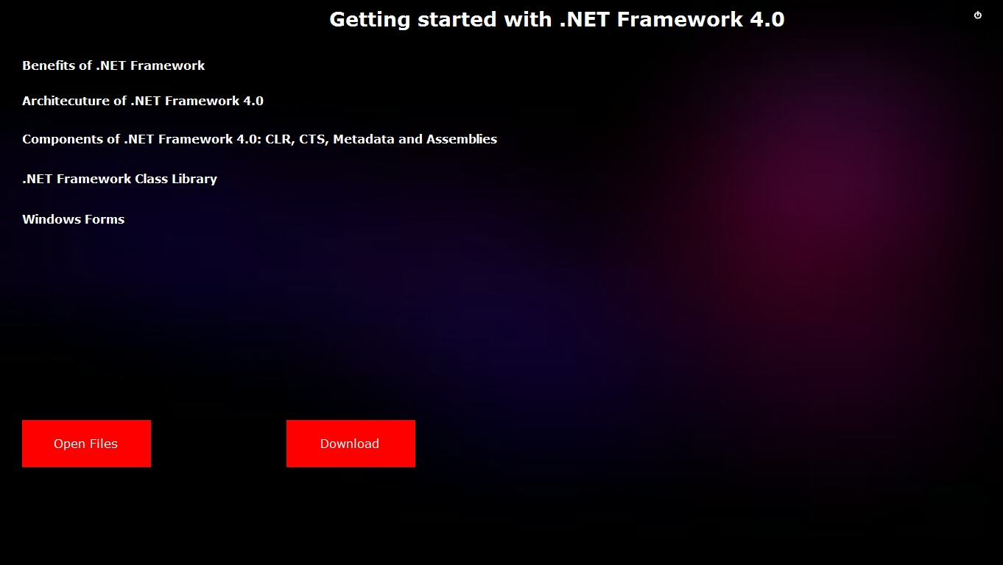**Chapter1 Page:**

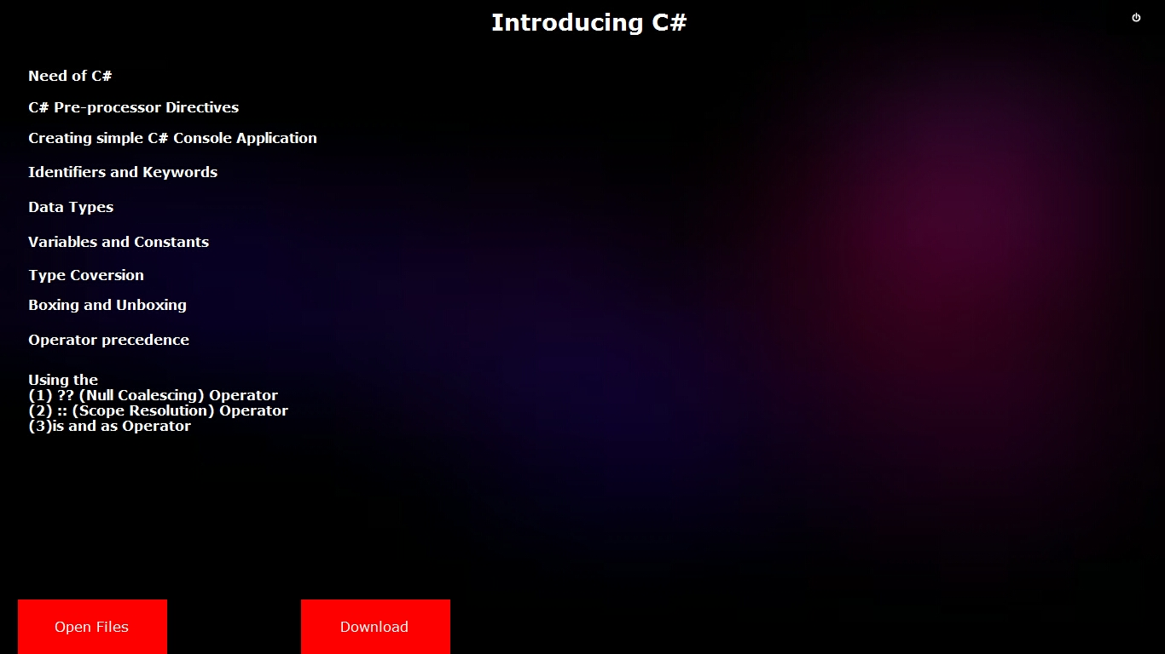**Chapter2 Page:**

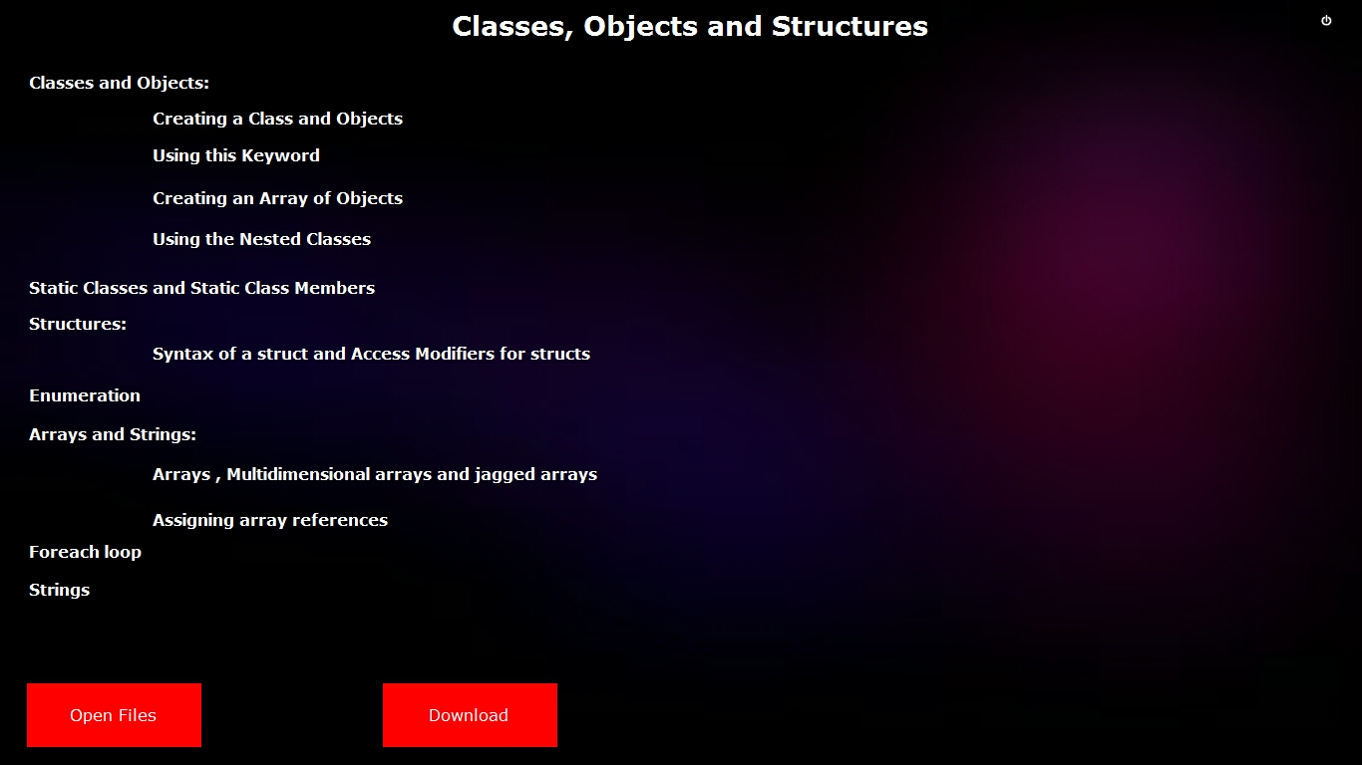**Chapter3 Page:**

**Chapter4 Page:**

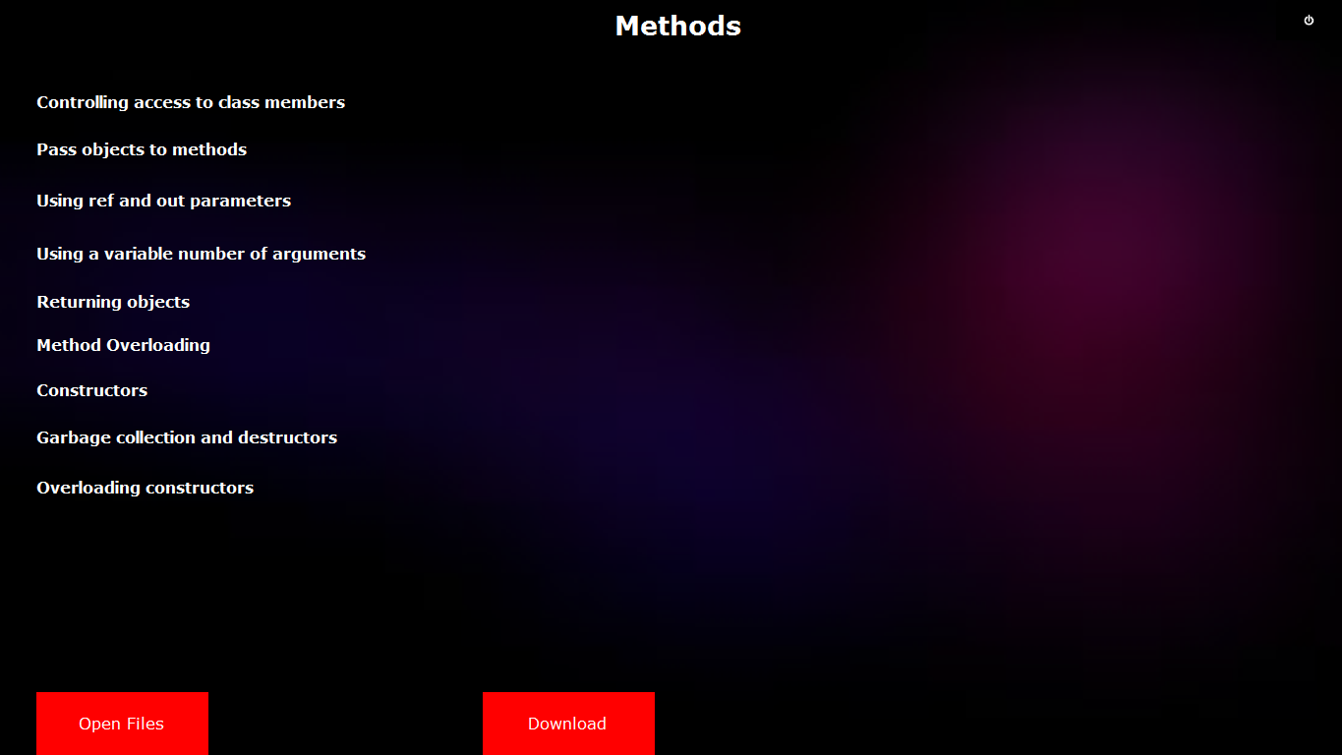

**Chapter5 Page:**

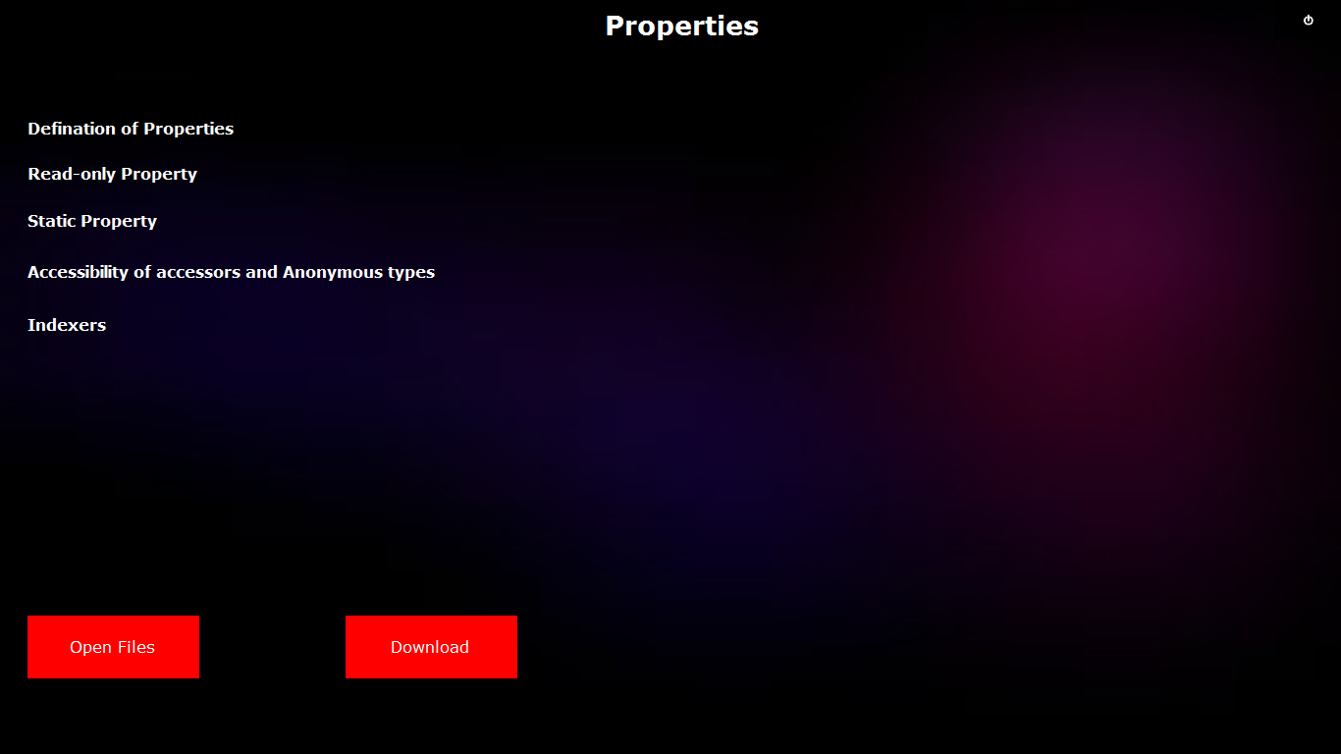

**Chapter6 Page:**

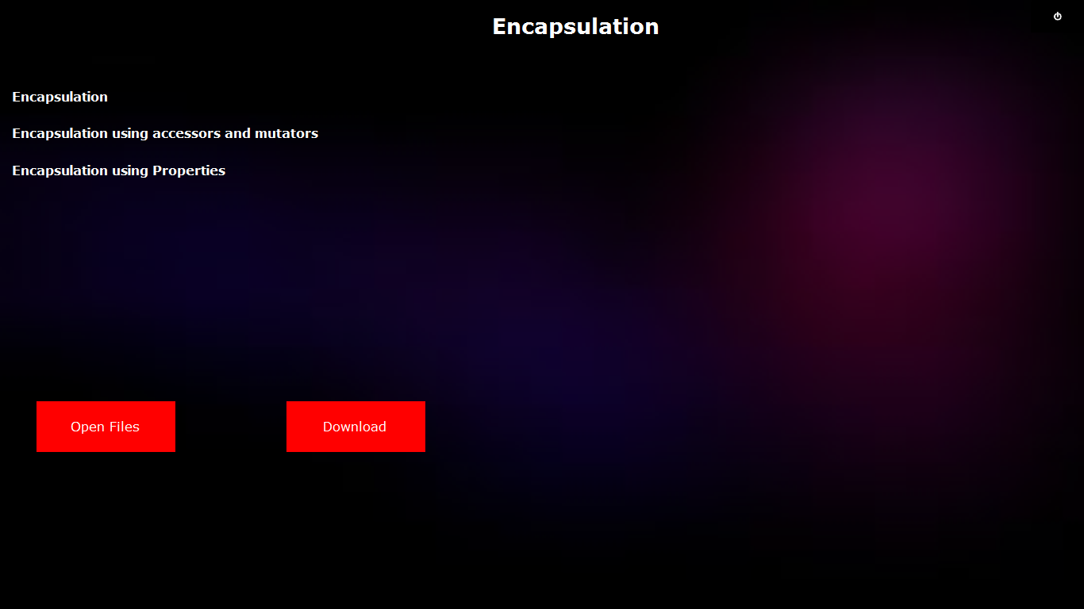

**Chapter7 Page:**

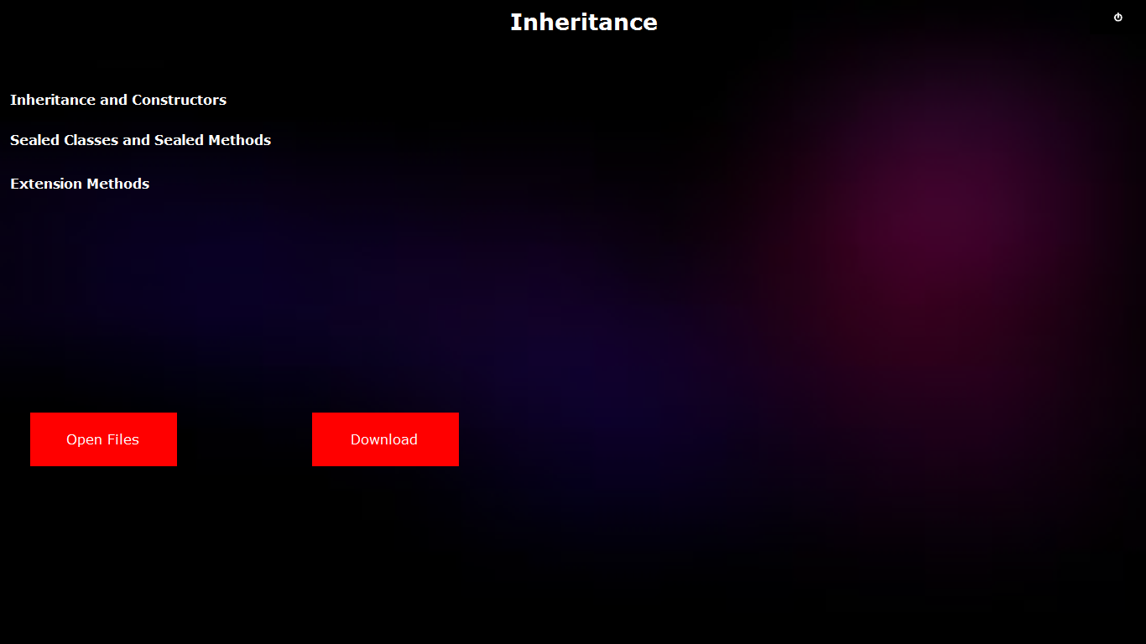

**Chapter8 Page:**

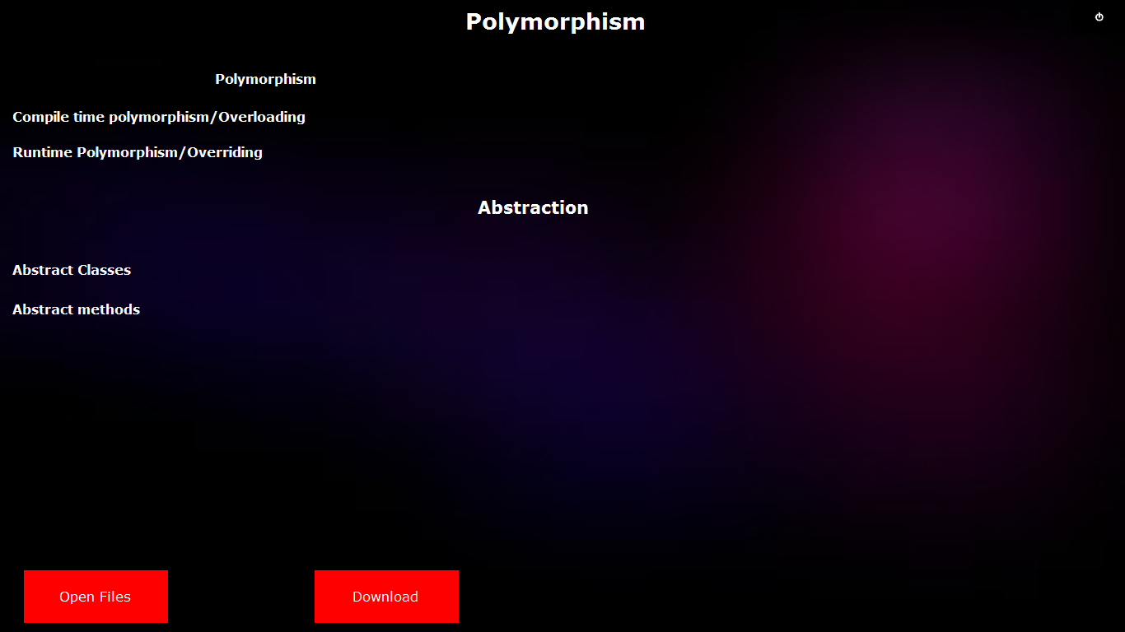

**Chapter9 Page:**

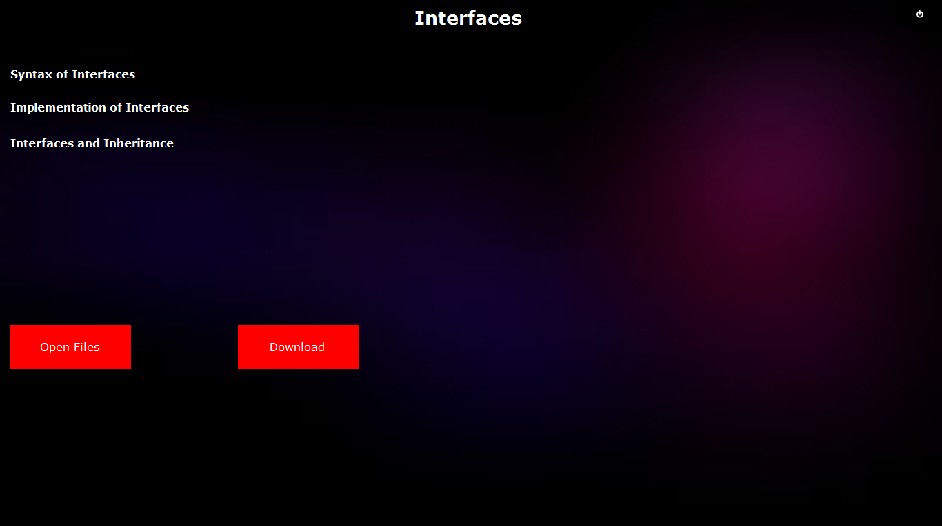

**Chapter10 Page:**

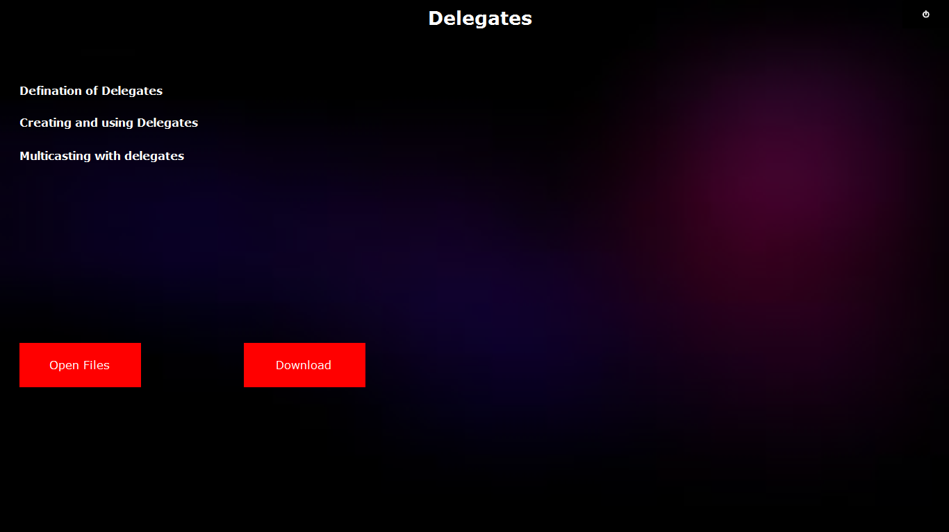

**Chapter11 Page:**

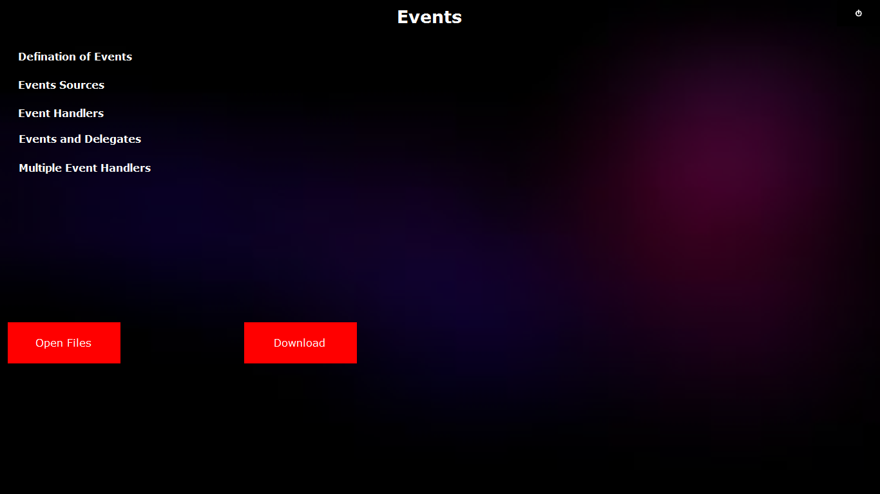

**Chapter12 Page:**

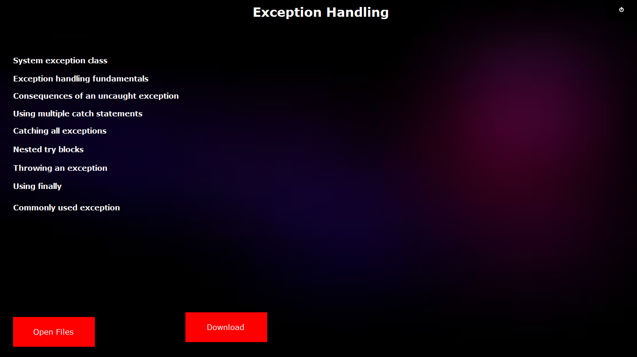

**Chapter13 Page:**

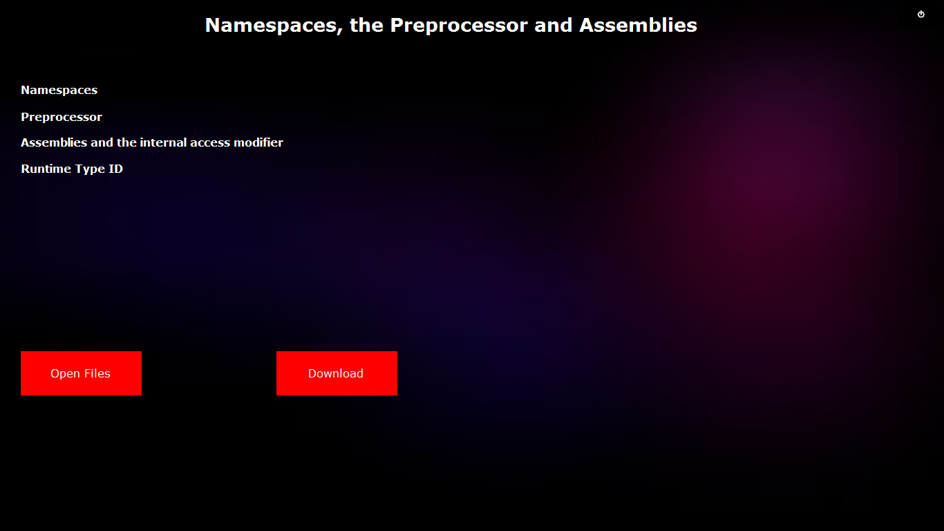

**Chapter14 Page:**

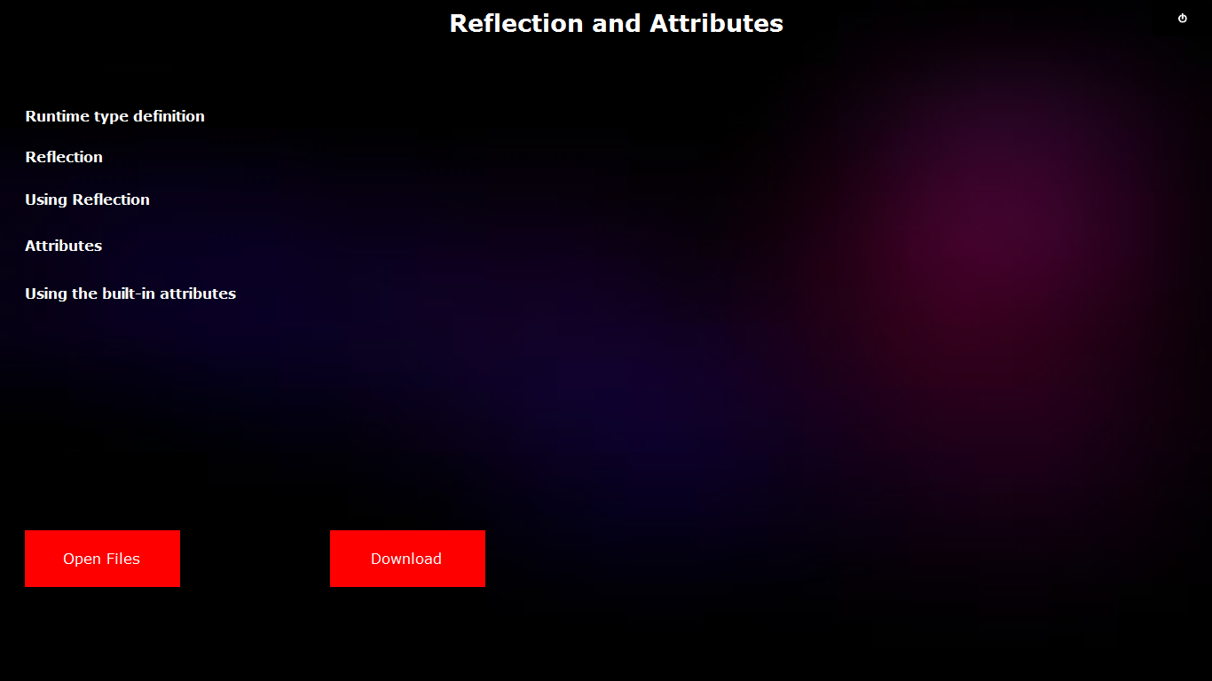

**Chapter15 Page:**

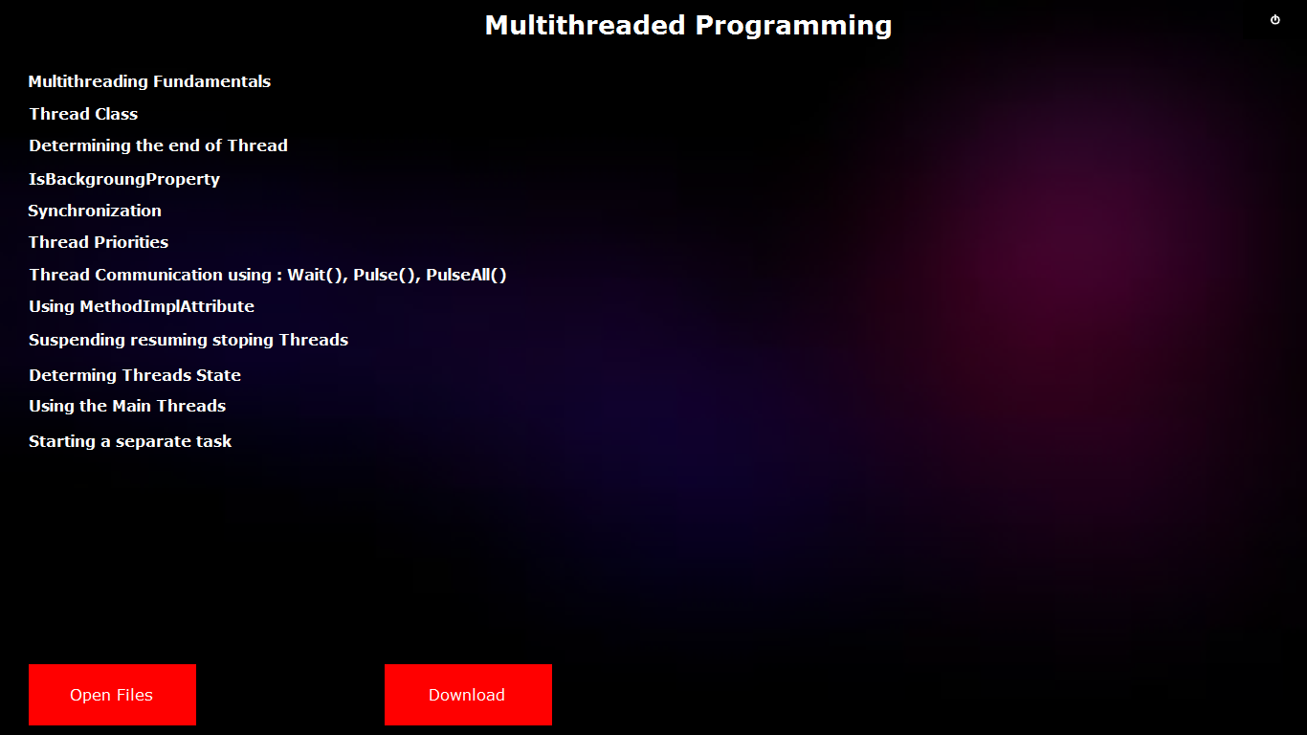

**Chapter16 Page:**

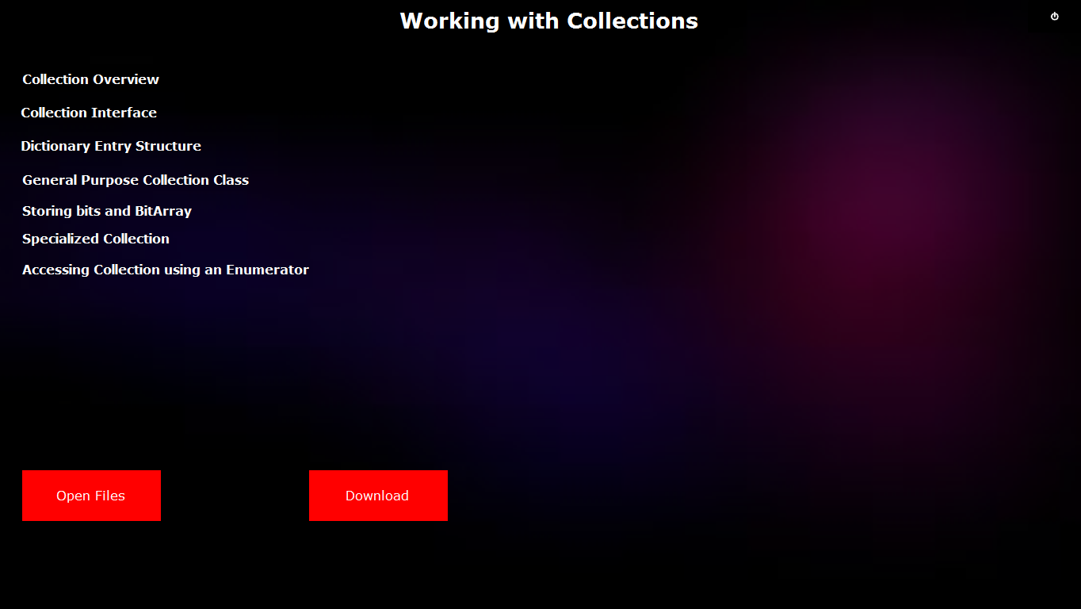

**Chapter17 Page:**

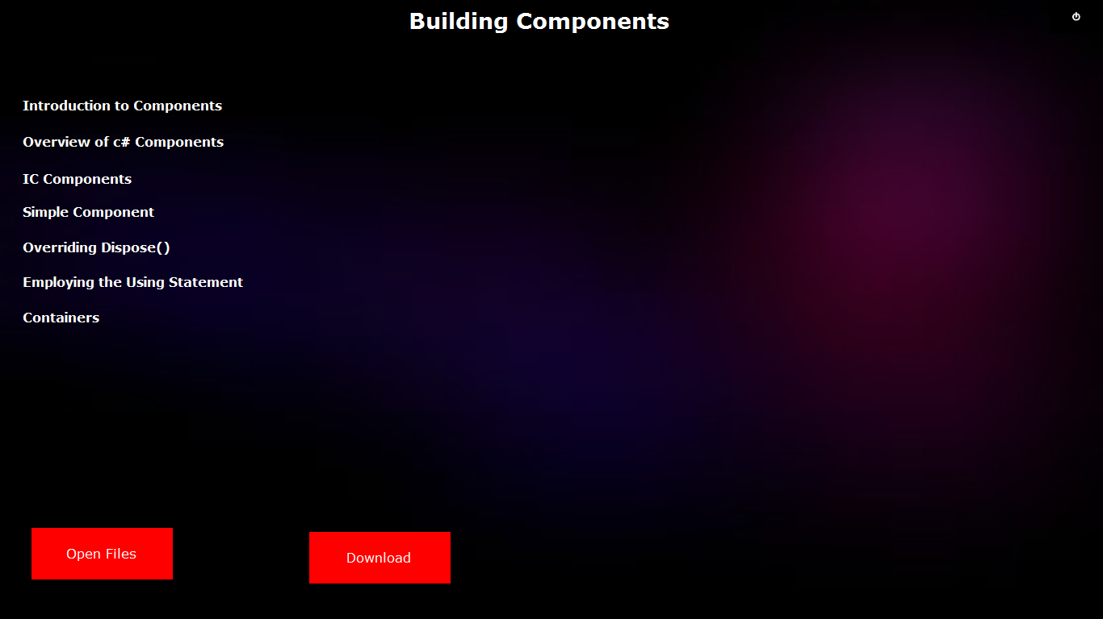

**Chapter18 Page:**

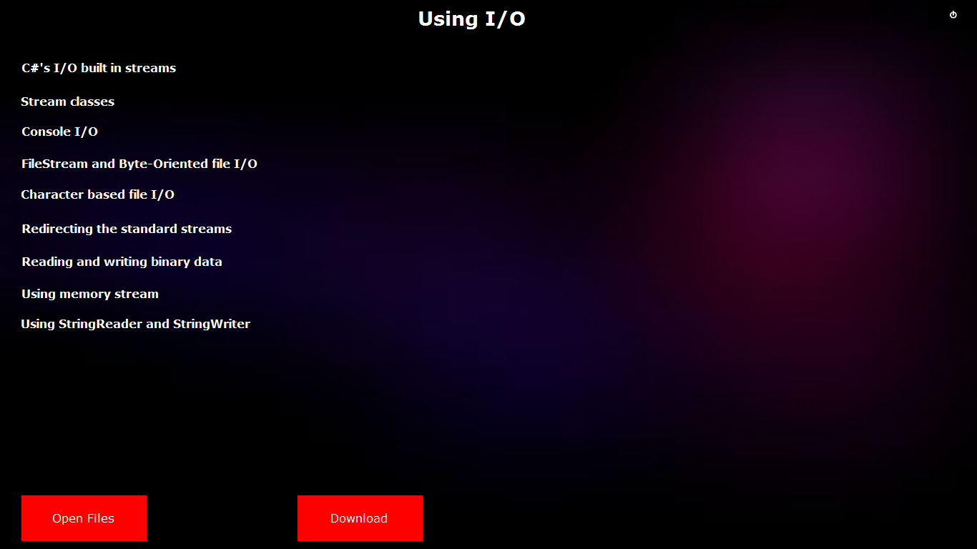

**Chapter19 Page:**

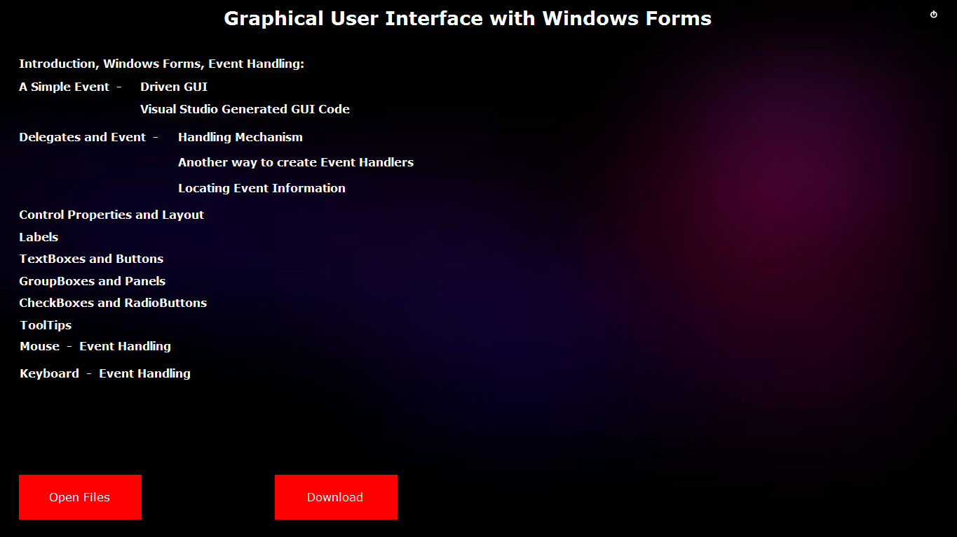

**Chapter20 Page:**

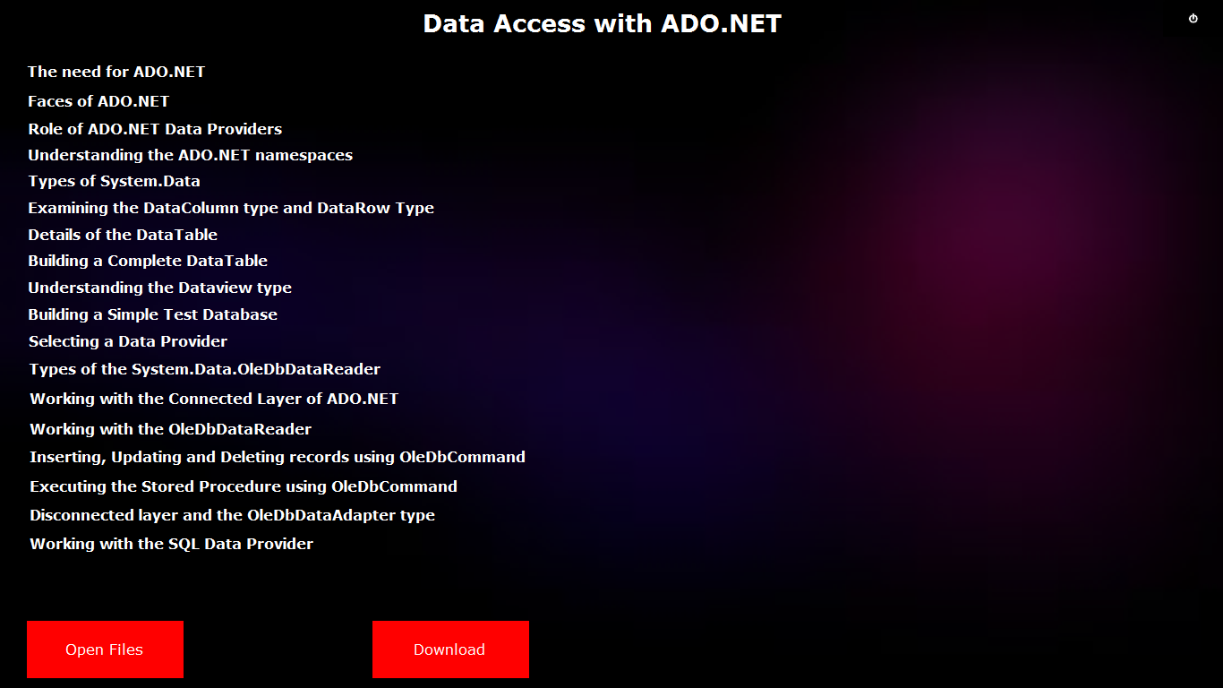

**Chapter21 Page:**

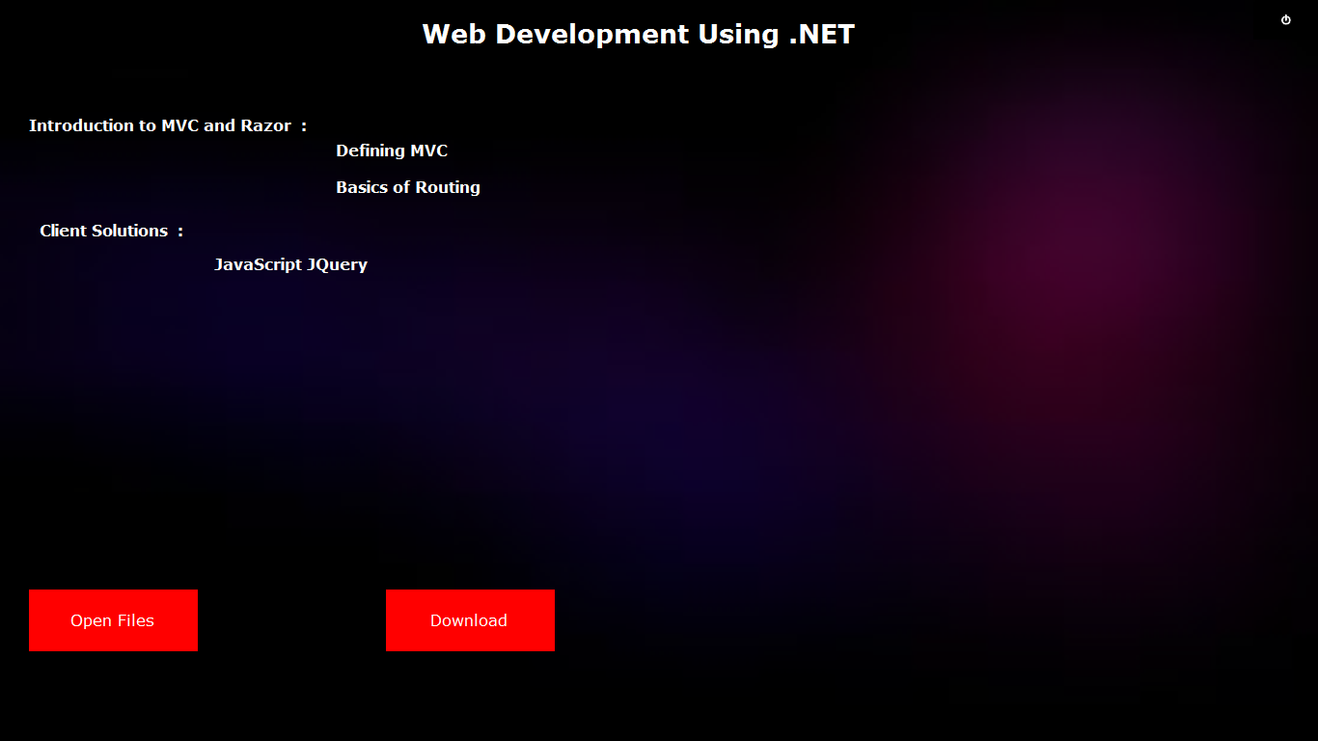

1. **Advantages:**

* User can easily read the contents in the chapter.
* Also user can modify the contents, update the contents and delete the contents in the topic.
* User can read the contents either by Word file or by Image.
* There is no need for users to maintain records about the contents in chapter. They can view the details through the user’s dashboard.
* User can Download and save the file as he required.

1. **Drawbacks:**

* At a time user cannot open more than one file.
* Once the topic of the chapter is deleted, again user cannot read the contents.

1. **References:**

* Google - [www.Google.com](http://www.Google.com)
* Wikipedia - www.wikipedia.com
* Stack Overflow - www.stackoverflow.com